A Model of Image Degradation?
Image degradation refers to the distortion of an ideal image due to blurring and noise during acquisition, transmission, or storage. A mathematical model helps us understand and reverse this degradation.
Spatial Domain Model:
g(x,y)=f(x,y)∗h(x,y)+n(x,y)
Where:
- f(x, y): Original image
- h(x, y): Degradation filter (e.g., motion blur)
- *: Convolution operation
- n(x, y): Additive noise
- g(x, y): Degraded image
Frequency Domain Model:
Using Fourier Transform:
G(u,v)=F(u,v)⋅H(u,v)+N(u,v)
Where:
- F,H,N: Fourier transforms of f,h,n.
- G(u,v): Degraded image in frequency domain
Restoration:
To recover the original image:
F(u,v)=(G(u,v)−N(u,v))/H(u,v)
Issues:
- Exact noise N(u,v) is unknown.
- If H(u,v) is close to zero, division causes instability.
Noise (in image)
Noise in an image refers to random or unwanted variations in pixel intensity that degrade visual quality. It may appear as speckles, grain, or sudden black/white dots, and is typically caused by sensor errors, transmission faults, or environmental interference.

FFT (Fast Fourier Transform)
FFT is an algorithm that transforms an image from the spatial domain to the frequency domain. It enables analysis of periodic patterns and facilitates frequency-based filtering, such as removing periodic noise or enhancing specific frequency components.
Types of Noise in Digital Images?
Salt-and-Pepper Noise:
Salt-and-pepper noise is a type of impulse noise characterized by sudden occurrences of black (pepper) and white (salt) pixels in an image.
This noise typically arises due to transmission errors, faulty memory locations, or bit flipping during image acquisition or transfer.
Mathematical Model
I(x,y) = 0;with probability p/2(pepper)
255;with probability p/2(salt)
I(x,y);with probability 1−p
Where:
- I(x,y) is the noisy image
- p is the noise density (probability of corruption)

Gaussian Noise:
Gaussian noise is an additive noise where the pixel intensity values are altered by values drawn from a normal (Gaussian) distribution.
This noise is commonly caused by sensor imperfections, thermal fluctuations, or poor lighting conditions.
Mathematical Model
g(x,y)=f(x,y)+n(x,y)
Where:
- g(x,y) is the noisy image
- f(x,y) is the original image
- n(x,y)∼N(0,σ2) is the Gaussian noise with mean 0 and variance σ2
Speckle Noise:
Speckle noise is a multiplicative noise that introduces granular distortions in images, especially in coherent imaging systems like radar, ultrasound, and SAR.
It is caused by interference of coherent waves reflected from rough surfaces.
Mathematical Model
g(x,y)=f(x,y)+f(x,y)⋅n(x,y)
Where:
- g(x,y) is the noisy image
- f(x,y) is the original image
- n(x,y) is the multiplicative noise component

Periodic Noise:
Periodic noise is a structured, sinusoidal interference that appears as repetitive patterns such as stripes or waves in an image.
This type of noise is typically caused by electrical interference, mechanical vibrations, or faulty scanning devices.

Mathematical Model
n(x,y)=A⋅sin(2πux+2πvy)
Where:
- A is the amplitude of the noise
- u, v are the spatial frequencies
- x, y are the pixel coordinates

corresponding filter for cleaning those noise?
Salt-and-Pepper Noise → Median Filter
Median filter is a non-linear filter that replaces each pixel with the median value of its neighborhood. Unlike mean filters, it effectively removes outliers without blurring edges.
Equation:
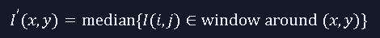

Gaussian Noise → Gaussian Filter / Wiener Filter
Gaussian filter uses a weighted average where central pixels get more weight. It smooths the image and reduces high-frequency noise.
Kernel Equation:
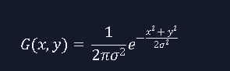
Wiener Filter:
Wiener filter is an adaptive linear filter that minimizes the mean square error (MSE) between the restored and original image. It works in the frequency domain, considering both the degradation function and noise statistics.

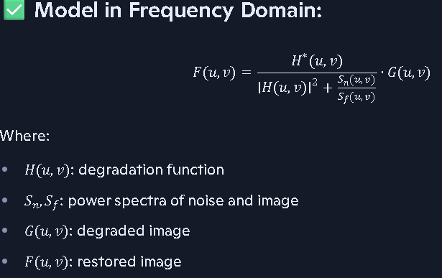

Speckle Noise → Adaptive Filter
Adaptive filters calculate local mean and variance to adjust the filtering strength dynamically. Smooth regions get more filtering, while edges are preserved.
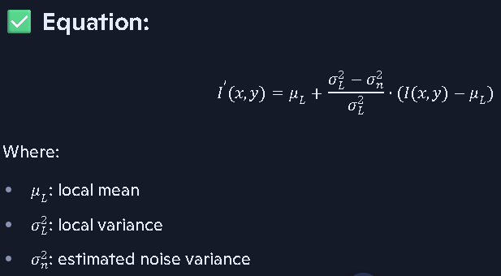
Periodic Noise → Notch Filter (Frequency Domain)
Notch filters are designed to remove these specific frequencies without affecting the rest of the image. It’s applied in the Fourier domain.
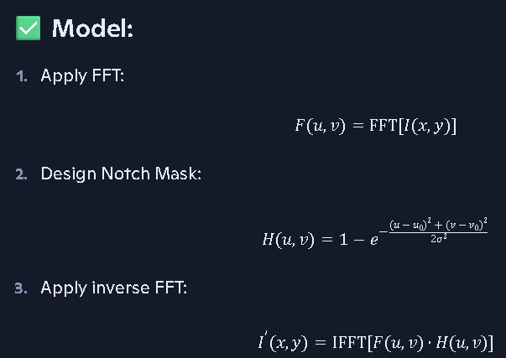
An Outlier Method (for Noise Reduction)
The Outlier Method is a simple noise reduction technique that detects and replaces noisy pixels by comparing them with the local average of their neighborhood. If a pixel deviates too much from its neighbors, it is considered an outlier and replaced. It works well for impulse noise and is computationally efficient.
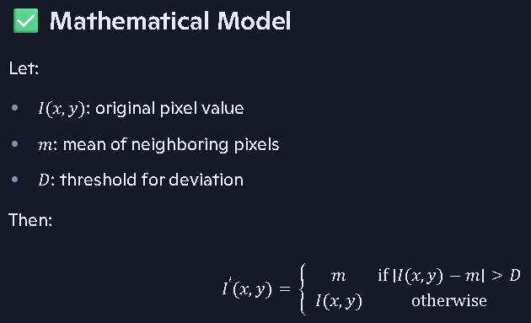

Inverse Filtering (Image Restoration Technique)
Inverse filtering is a frequency domain technique used to recover a blurred image by reversing the effect of the degradation function. It assumes that the degradation (blur) is known and tries to undo it mathematically.
inverse filtering attempts to restore the original image by dividing the degraded image’s Fourier transform by the degradation function’s Fourier transform.

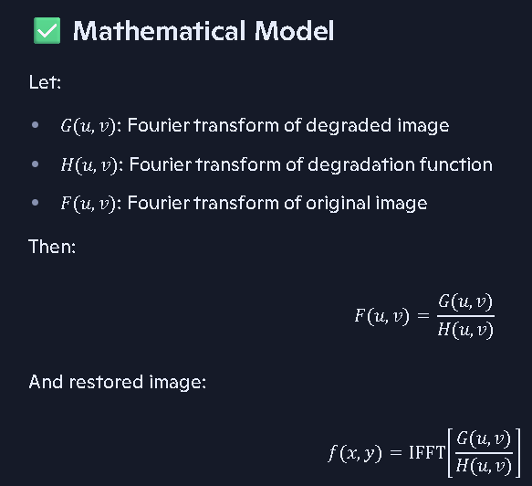
Single Thresholding
Single thresholding is a basic image segmentation technique where a single threshold value T is used to separate foreground from background. Pixels above the threshold are classified as one class (e.g., object), and those below as another (e.g., background).
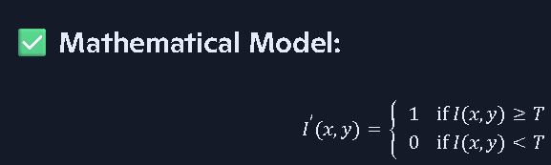
Double Thresholding
Double thresholding uses two threshold values, T1 and T2, to classify pixels into three categories: strong, weak, and irrelevant. It is commonly used in edge detection to refine results and reduce false positives.
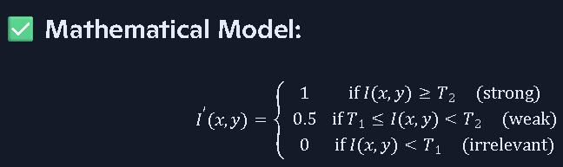
write the difference the single thresholding and double thresholding?
Key Differences (Explained in 5 Points)
- Threshold Count: Single thresholding uses only one value to divide the image, while double thresholding uses two values to create three zones — strong, weak, and discard.
- Segmentation Depth: Single thresholding gives a binary result (0 or 1), whereas double thresholding provides a more nuanced classification, allowing conditional inclusion of weak pixels.
- Robustness: Double thresholding is more robust in noisy or gradient-rich images, as it avoids sudden decisions. Single thresholding may misclassify pixels near the threshold.
- Application Domain: Single thresholding is used in simple binary segmentation tasks like document binarization. Double thresholding is used in advanced tasks like edge detection and medical imaging where precision matters.

application of thresholding in image processing?
- Image Segmentation
Thresholding is widely used to separate objects from the background. This is especially useful when the object has a distinct intensity compared to its surroundings.
- Document Binarization
Thresholding is essential in converting grayscale scanned documents into binary images for OCR (Optical Character Recognition).
- Medical Imaging
Thresholding helps in identifying regions of interest (ROI) in medical scans like MRI, CT, or X-ray images.
- Background Subtraction in Video Surveillance
Thresholding helps in detecting moving objects by subtracting the background and applying a threshold to the difference.

- Chemical and Biological Image Analysis
Thresholding is used to count cells, measure growth, or detect stained regions in microscopic images.

adaptive thresholding?
Adaptive thresholding is a technique where the threshold value is not fixed globally, but instead calculated locally for each pixel based on the surrounding neighborhood. This makes it ideal for images with varying illumination.
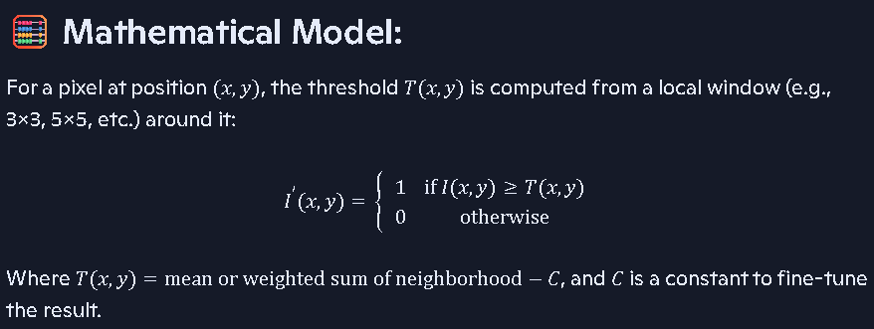
- Roberts Cross Operator
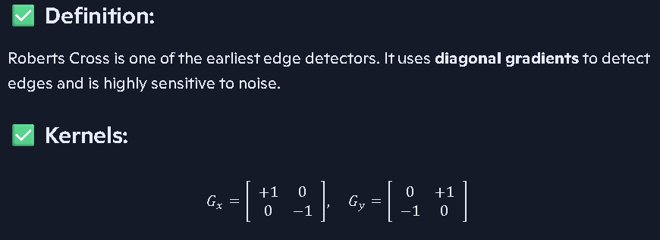
- Prewitt Operator
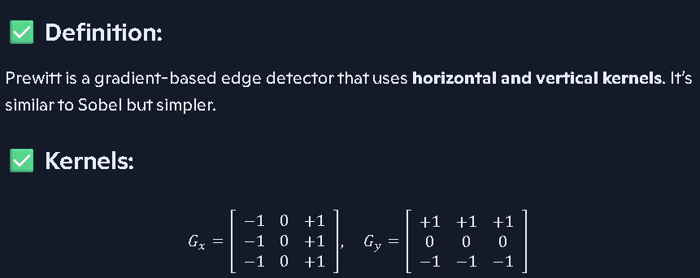

- Sobel Operator
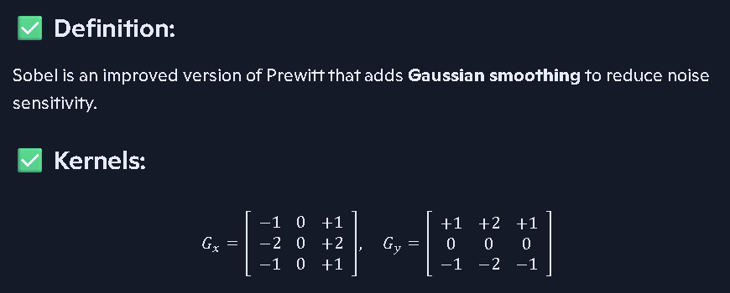
compare prewitt, roberts cross gradients, sobel filters in details?
Deep Comparison in 5 Points
- Kernel Size and Directionality: Roberts uses 2×2 kernels and detects diagonal edges. Prewitt and Sobel use 3×3 kernels and detect horizontal/vertical edges.
- Noise Sensitivity: Roberts is highly sensitive to noise due to lack of smoothing. Prewitt is moderately sensitive. Sobel is least sensitive because it includes Gaussian-like smoothing.
- Edge Accuracy vs. Robustness: Roberts gives sharp but noisy edges. Prewitt gives clean edges but may miss subtle ones. Sobel balances edge sharpness and noise suppression.
- Computational Cost: Roberts is fastest due to small kernel. Prewitt is simple and fast. Sobel is slightly heavier but still efficient for real-time use.
- Use Case Suitability:
  - Roberts: Best for simple, clean images or diagonal edge emphasis
  - Prewitt: Good for academic use or clean environments
  - Sobel: Preferred in practical applications like medical imaging, object detection, and noisy scenes
define discreate Laplacian?
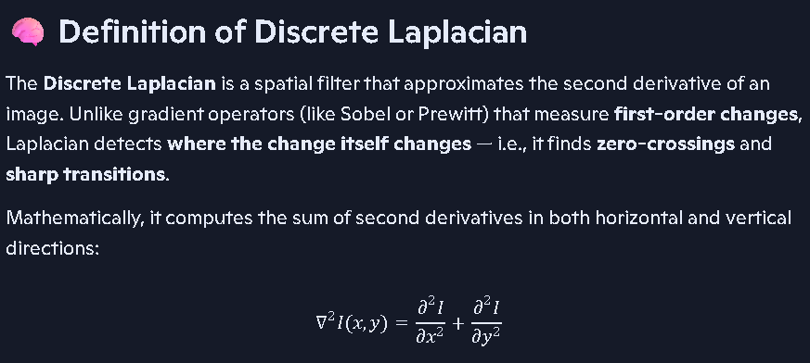
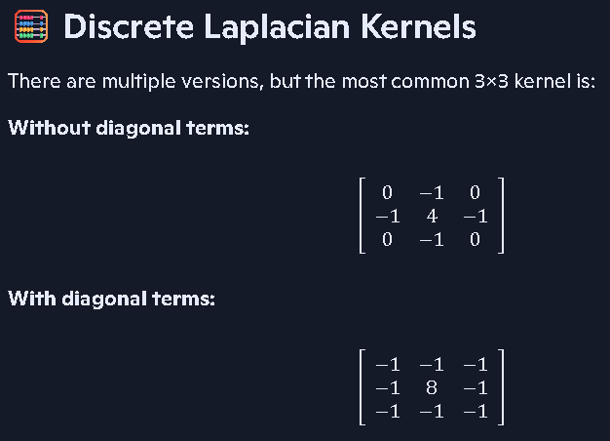

zero crossing?
Zero crossing refers to the point in a function (or image) where the sign of the value changes — from positive to negative or vice versa. In image processing, it marks the location where the second derivative of intensity changes sign, indicating a potential edge.

This means the pixel is at a transition point — a peak, valley, or inflection — where intensity changes sharply.

